

**SKILLS & JOB**

**RECOMMENDER**

**APPLICATION**

**SAVEETHA ENGINEERING COLLEGE,CHENNAI**

IBM MENTOR **DR.NIRMALADEVI.K**

**GUIDED BY DR.NIRMALADEVI.K**

PRESENTED BY

|  |  |
| --- | --- |
| SHESHATHRI V M | (212219060246) |
| SENTHILNATHAN S | (212219060235) |
| SHAIK MUHAMMAD AASIF | (212219060241) |
| SRIKANTA YESWANTH ADITHYA | (212219060256) |

**CONTENT**

ABSTRACT INTRODUCTION NOVELTY FEASIBILITY BUSINESS MODEL SOCIAL IMPACT SCALABILITY CONCLUSION REFERENCE

**CLOUD APPLICATION DEVELOPMENT**

**Spinz.co**

2



# ABSTRACT

* Job skills are all the skills you use to complete your work from workplace skills like time management to technical skills like programming.
* Use 'action' words such as achieved, awarded, organised, led, assisted, managed, increased, developed, built or won. Use positive words to describe yourself and your achievements such as accurate, willing to learn, organised, hardworking, dependable, motivated or creative.

3



# INTRODUCTION

* The Introduction to Skills for Work ( ISFW) is a programme, designed by teachers for teachers, and focused on developing the self-awareness of pupils skills and strengths.
* This free online course, Introduction to Job Search Skills, is designed to give anyone who is looking for work the skillset they need to find the job they are searching for. Searching for a new job is both an exciting and stressful process. From students looking for internships to experienced professionals, job search skills can be invaluable for almost everyone. With this free online course, gain a few more of these skills, today.

# NOVELTY

* + Simply put, it is a system that gives us recommendations based on the data that it has collected from us, and other users like us, over a course of time. These systems today, work in areas like movies, music, news, research articles, search queries, restaurants, hashtags, and more.

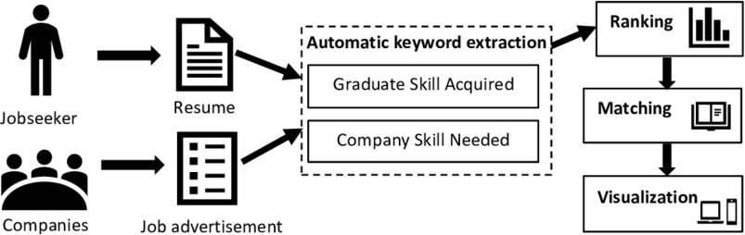



# FEASIBILITY

* skills required for conducting a good feasibility study: environmental analytical skills, market analysis skill, technical analysis skills, economic analysis skills and financial analysis skills**.**

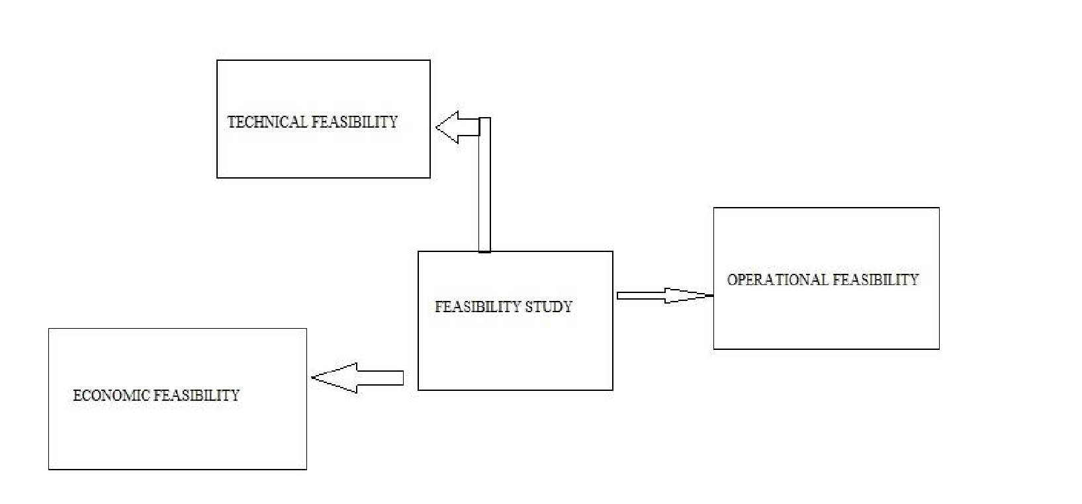



# BUSINESS MODEL

* “**Spinz.co**” connects you with other professionals also with companies and recruiters. Along with professionals, it also serves companies and even charges for providing certain premium services.
* “**Spinz.co**” is solution to increase your professional network and find new opportunities. Be it finding new networking opportunities, potential employees, marketing of new campaigns, searching for a sales lead or learning business concepts, “**Spinz.co**” business solutions have services to fulfil most of these needs.

**SOCIAL IMPACT**

* At Last We Believe That Two People With Equal Talent Should Have Equal Access To Oppurtnity And We’re Committed To Making This Vision Reality Through Our Global Social Impact Programs.
* We Create Opportunities For “**Spinz.co”** Employees To Engage In Social Impact By Contributing Their Skills And Time To Support Their Communities.
* Workshops Include But Are Not Limited To :Speed Mentoring “**Spinz.co**” Training Sessions and

Skill-based Coaching.

**SCALABILITY**

* + Scalability is a custom training and organizational development firm dedicated to helping businesses scale.
  + And also improve job opportunities to freshers and unemployed person and also carrier development to the

industrial and organization.

* + Today, “**Spinz.co**” operates globally with more than 350 million members. We serve tens of thousands of web pages every second of every day. We've hit our mobile moment where mobile accounts for more than 50 percent of all global traffic. All those requests are fetching data from our backend systems, which in turn handle millions of queries per second.
  + “**Spinz.co**” continues to grow quickly and there’s still a ton of work we can do to improve. We’re working

on problems that very few ever get to solve



**CONCLUSION**

we used a literature analysis of many journals and proceedings related to the recruiting process and the job recommendation researches. We have seen from our literature review and from the challenges that faced the e-recruiting platforms, an increased need for enhancing the quality of candidates/job matching. The recommender system technologies accomplished significant success in a broad range of applications and potentially a powerful searching and recommending techniques. Consequently, there is a great opportunity for applying these technologies in recruitment environment to improve the matching quality. This survey shows that several approaches for job recommendation have been proposed, and many techniques combined in order to produce the best fit between jobs and candidates. We presented state of the art of job recommendation as well as, a comparative study for its approaches that proposed by literatures. Additionally, we reviewed typical recommender system techniques and the recruiting process related issues. We conclude that the field of job recommendations is still unripe and require further improvements.





REFERENCE



12